**Green Campus Clean campus Cell**

**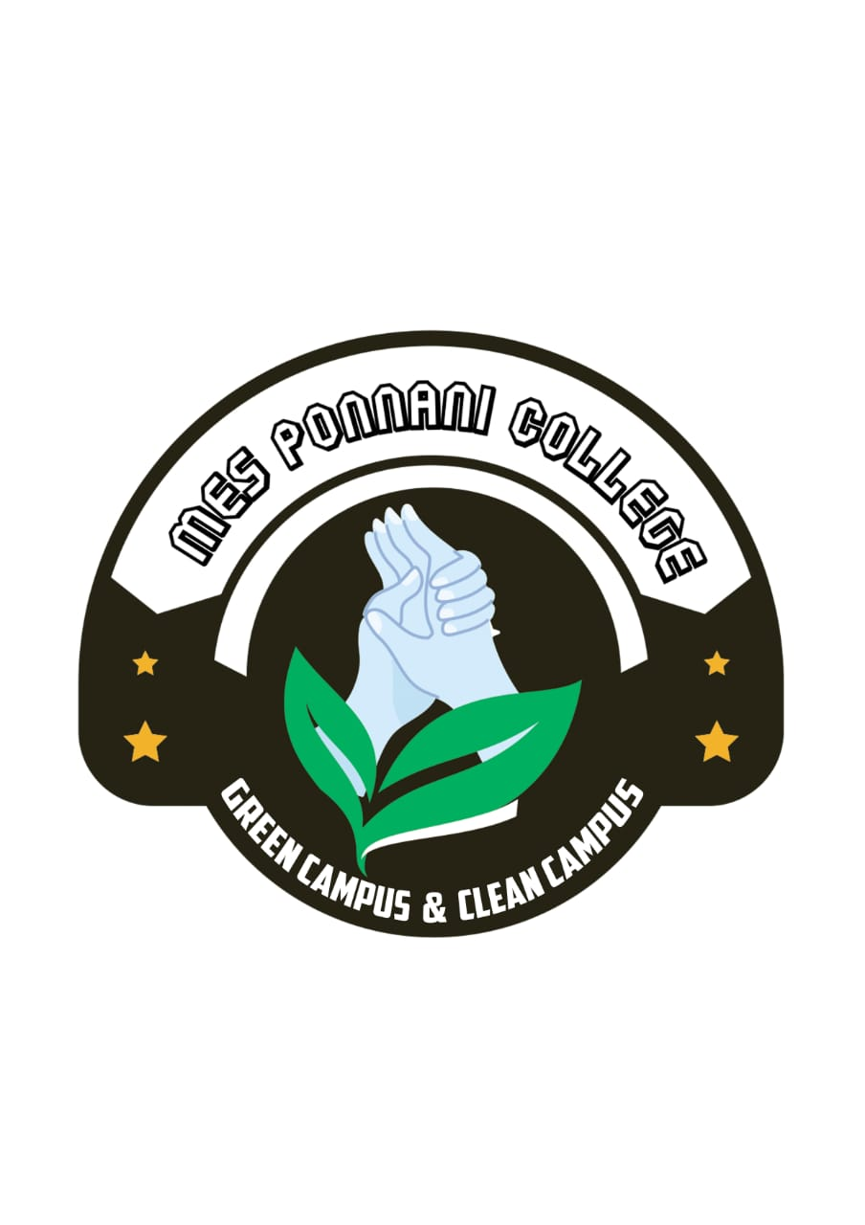**

**GREEN CAMPUS CLEAN CAMPUS CLUB REPORT 2017-2018**

|  |  |  |
| --- | --- | --- |
| Convener | Mrs. Asha Neendur | C:\Users\user\Desktop\Asha miss-Photo.jpg |
| Joint Convener | Smt. Shamila. V.U | C:\Users\user\Desktop\attachments\Shamila Miss Photo.jpg |
|  | Smt. K. Safna | C:\Users\user\Desktop\attachments\IMG_9522.JPG |
|  | Dr. Mujeeb Rahiman | C:\Users\user\Desktop\Mujeeb-Photo.jpg |
| Student Co-Ordinator | Ablish. C.P | C:\Users\user\Desktop\attachments\Abilash.jpg |

Students cleaned the campus on 14th August 2017 and all the deparmetn students actively participated in this programme

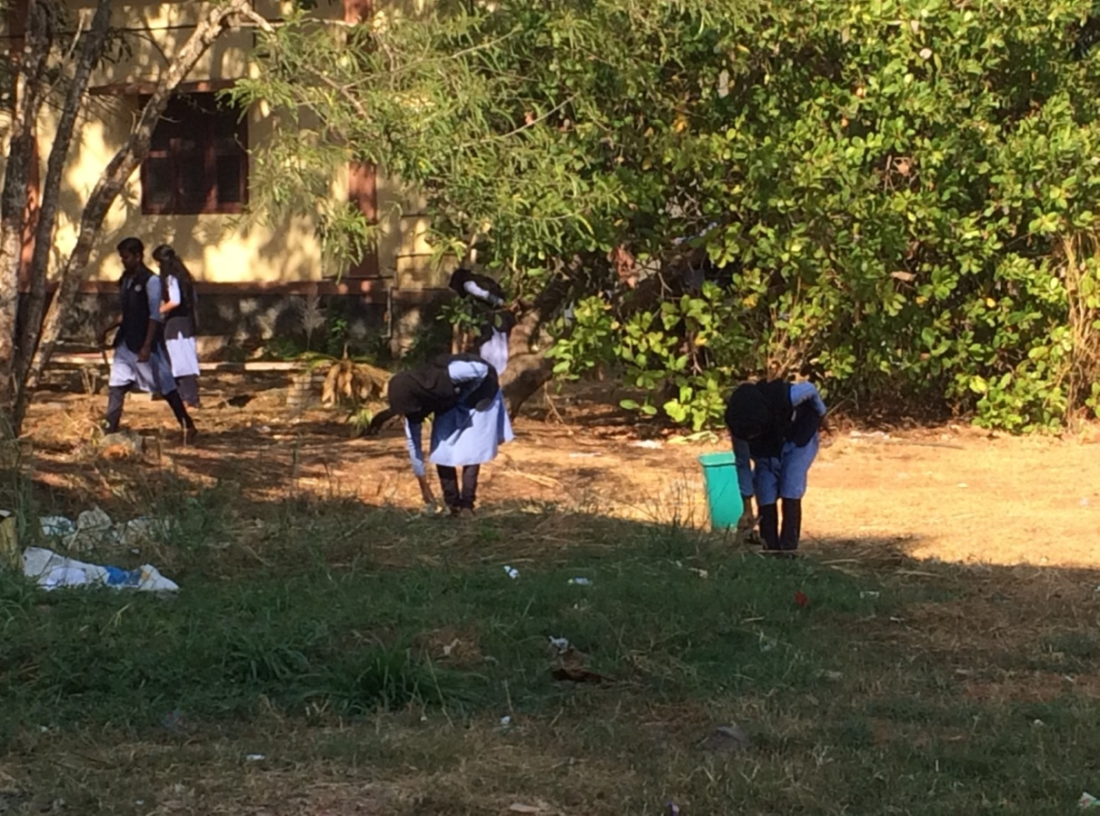

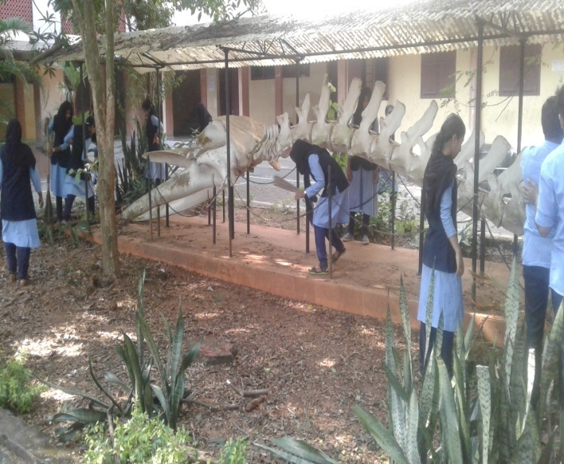

The first meeting of the club was held on 12th September 2017. The meeting was held to select the members of the club .On 18th October 2017a meeting was held to conduct a campus cleaning drive. A campus cleaning competition was conducted on 19 th October 2017.All the departments actively participated in this drive. Department of Physics and department of Commerce won the prize. The members of the club regularly planting trees ,and cultivated vegetables on green bags.

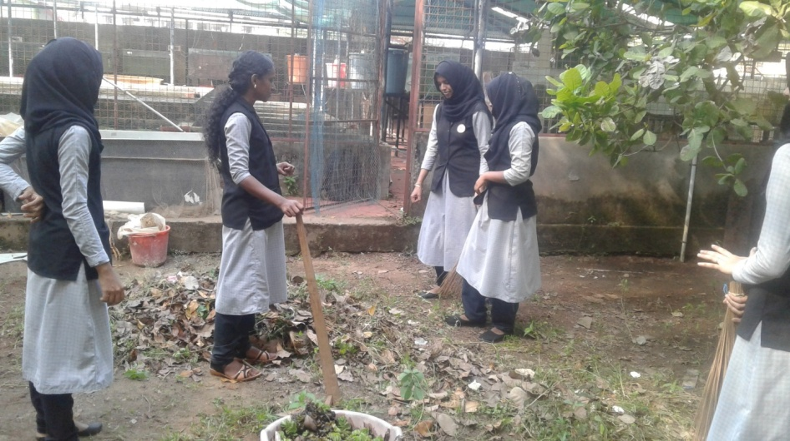

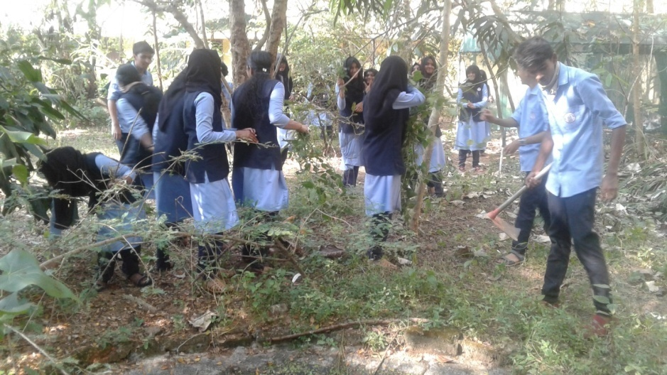

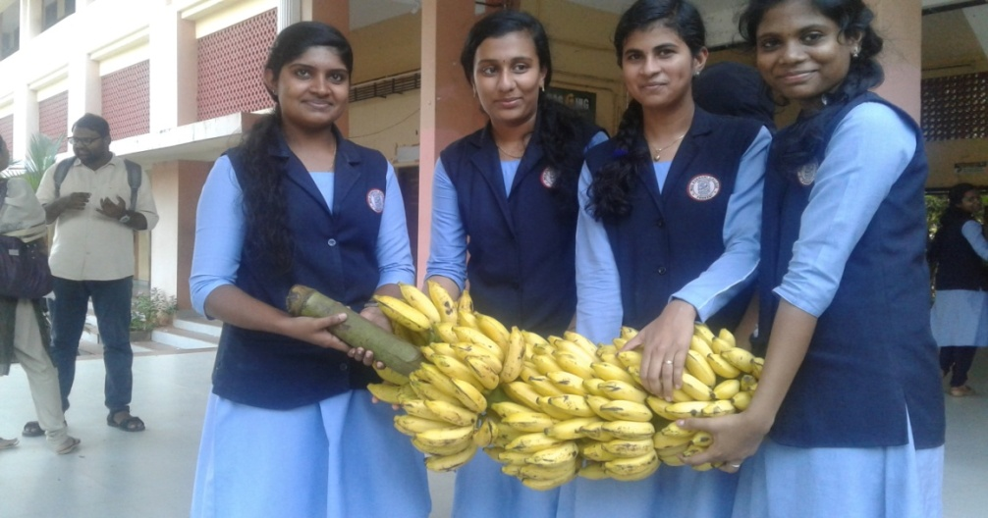

Students actively participated in a clening programme on 14th January 2018.

